**Python Operator Overloading: A Comprehensive Guide**

[[Rinu Gour](https://medium.com/@rinu.gour123?source=post_page-----c96c22176646--------------------------------)](https://medium.com/@rinu.gour123?source=post_page-----c96c22176646--------------------------------)

[[PythonFlood](https://pythonflood.com/?source=post_page-----c96c22176646--------------------------------)](https://pythonflood.com/?source=post_page-----c96c22176646--------------------------------)

[Rinu Gour](https://medium.com/@rinu.gour123?source=post_page-----c96c22176646--------------------------------)

·

[Follow](https://medium.com/m/signin?actionUrl=https%3A%2F%2Fmedium.com%2F_%2Fsubscribe%2Fuser%2Fd8b99ba6ec83&operation=register&redirect=https%3A%2F%2Fpythonflood.com%2Fpython-operator-overloading-a-comprehensive-guide-c96c22176646&user=Rinu+Gour&userId=d8b99ba6ec83&source=post_page-d8b99ba6ec83----c96c22176646---------------------post_header-----------)

Published in

[PythonFlood](https://pythonflood.com/?source=post_page-----c96c22176646--------------------------------)

·

8 min read

·

4 days ago

72

In Python, you can specify how operators act for unique objects by using operator overloading. It offers the option to change how built-in operators, including “+”, “-”, “*”, “/”, “==”, “!=”, “,” and “>” behave. The fundamental ideas and methods of operator overloading in Python will be covered in this guide, along with code snippets and examples that produce results.

**1. How to Overload Operators:**

You must define special methods, commonly referred to as magic methods or dunder methods, which are prefixed and suffixed with double underscores, in order to overload operators. These methods specify how operators behave when used on items from your special class.

**Example:**

class Point:  
 def __init__(self, x, y):  
 self.x = x  
 self.y = y  
  
 def __add__(self, other):  
 new_x = self.x + other.x  
 new_y = self.y + other.y  
 return Point(new_x, new_y)  
  
point1 = Point(1, 2)  
point2 = Point(3, 4)  
  
result = point1 + point2  
print(result.x, result.y)

**Output:**4 6

**Explanation:**In this illustration, a point in a 2D coordinate system is represented by the Point class. The addition operator + is overloadable by the __add__ function. It adds the corresponding coordinates to another Point object it is given as an argument, then returns a fresh Point object.



**2. Creating a Custom Class and Implementing Operator Overloading:**

You can specify how your class interacts with the Python operators (+, -, *, /, etc.) by developing a custom class and implementing operator overloading. This facilitates easy interaction with typical Python functions and makes your code more understandable and legible. Here’s an illustration: In order to overload the addition and subtraction operations, let’s develop a custom 2D point class:

**3. Operator and Magic Methods:**

Magic methods are unique ways that specify how operators behave. Following are a few typical magic techniques for operator overloading:

class Point:  
 def __init__(self, x, y):  
 self.x = x  
 self.y = y  
  
 def __add__(self, other):  
 return Point(self.x + other.x, self.y + other.y)  
  
 def __sub__(self, other):  
 return Point(self.x - other.x, self.y - other.y)  
  
# Create two Point objects  
p1 = Point(1, 2)  
p2 = Point(3, 4)  
  
# Use the + operator to add points  
result_add = p1 + p2  
print(result_add) # Output: (4, 6)  
  
# Use the - operator to subtract points  
result_sub = p2 - p1  
print(result_sub)

**Output:** (2, 2)

**Explanation:**By using operator overloading, Python’s built-in operations are included in the behavior of your custom class. As a result, Python’s common operations are integrated more effectively and fluidly. This improves the code’s clarity, elegance, and expressiveness.

**3.1 Comparison Operators:**

In order to establish the relationship between two values or objects, comparison operators are needed.Python’s standard comparison operators in operator overloading includes:  
— `__eq__(self, other)`: Implements the equality operator (==).  
— `__ne__(self, other)`: Implements the inequality operator (!=).  
— `__lt__(self, other)`: Implements the less-than operator (<).  
— `__gt__(self, other)`: Implements the greater-than operator (>).  
— `__le__(self, other)`: Implements the less-than-or-equal-to operator (<=).  
— `__ge__(self, other)`: Implements the greater-than-or-equal-to operator (>=).

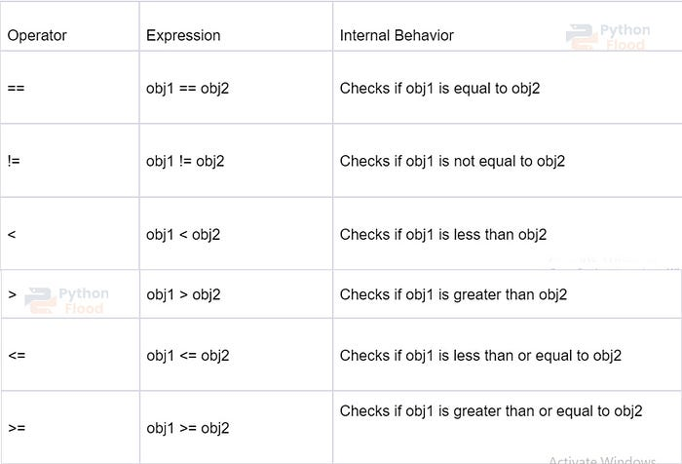

**Example of Comparison Operator:**

class Rectangle:  
 def __init__(self, width, height):  
 self.width = width  
 self.height = height  
  
 def __eq__(self, other):  
 return self.width == other.width and self.height == other.height  
  
 def __ne__(self, other):  
 return not self.__eq__(other)  
  
 def __lt__(self, other):  
 return self.area() < other.area()  
  
 def __gt__(self, other):  
 return self.area() > other.area()  
  
 def __le__(self, other):  
 return self.area() <= other.area()  
  
 def __ge__(self, other):  
 return self.area() >= other.area()  
  
 def area(self):  
 return self.width * self.height  
  
# Creating rectangles  
rect1 = Rectangle(4, 5)  
rect2 = Rectangle(3, 6)  
rect3 = Rectangle(4, 5)  
  
# Equality comparison  
print(rect1 == rect2) # Output: False  
print(rect1 == rect3) # Output: True  
  
# Inequality comparison  
print(rect1 != rect2) # Output: True  
print(rect1 != rect3) # Output: False  
  
# Less than comparison  
print(rect1 < rect2) # Output: False  
print(rect2 < rect3) # Output: True  
  
# Greater than comparison  
print(rect1 > rect2) # Output: True  
print(rect2 > rect3) # Output: False  
  
# Less than or equal to comparison  
print(rect1 <= rect2) # Output: False  
print(rect2 <= rect3) # Output: True  
  
# Greater than or equal to comparison  
print(rect1 >= rect2) # Output: True  
print(rect2 >= rect3) # Output: True

**Explanation:**In the code snippet provided above, the Rectangle class is rectangles with attributes including width and height. This Rectangle class is also defining various magic methods for overloading the comparison operators.  
1. __eq__ is determining equality by comparing the width and height of two rectangles.  
2. __ne__ is returning the negation of the equality comparison.  
3. __lt__ is comparing the areas of the two given rectangles to see if one is smaller than the other.  
4. __gt__ is comparing the areas of the two given rectangles to see if one is greater than the other.  
5. __le__is comparing the areas of the two given rectangles to see if one is less than or equal to the other.  
6. __ge__ is comparing the areas of the two given rectangles to see if one is greater than or equal to the other.

**3.2 Assignment Operators:**

Assignment operators in operator overloading enable customised actions when objects are assigned or changed by customizing the behavior of the assignment (=) operator for custom classes. Some assignment operators are provided below:  
— `__add__(self, other)`: Implements the addition operator (+).  
— `__sub__(self, other)`: Implements the subtraction operator (-).  
— `__mul__(self, other)`: Implements the multiplication operator (*).  
— `__truediv__(self, other)`: Implements the true division operator (/).  
— `__floordiv__(self, other)`: Implements the floor division operator (//).  
— `__mod__(self, other)`: Implements the modulo operator (%).  
— `__pow__(self, other[, modulo])`: Implements the exponentiation operator (**).

**Example of Assignment Operators:**

class Number:  
 def __init__(self, value):  
 self.value = value  
  
 def __add__(self, other):  
 return Number(self.value + other.value)  
  
 def __sub__(self, other):  
 return Number(self.value - other.value)  
  
 def __mul__(self, other):  
 return Number(self.value * other.value)  
  
 def __truediv__(self, other):  
 return Number(self.value / other.value)  
  
 def __floordiv__(self, other):  
 return Number(self.value // other.value)  
  
 def __mod__(self, other):  
 return Number(self.value % other.value)  
  
 def __pow__(self, other):  
 return Number(self.value ** other.value)  
  
 def __str__(self):  
 return str(self.value)  
  
# Create Number objects  
num1 = Number(10)  
num2 = Number(5)  
  
# += operator  
num1 += num2  
print(num1) # Output: 15  
  
# -= operator  
num1 -= num2  
print(num1) # Output: 10  
  
# *= operator  
num1 *= num2  
print(num1) # Output: 50  
  
# /= operator  
num1 /= num2  
print(num1) # Output: 10.0  
  
# //= operator  
num1 //= num2  
print(num1) # Output: 2.0  
  
# %= operator  
num1 %= num2  
print(num1) # Output: 2.0  
  
# **= operator  
num1 **= num2  
print(num1) # Output: 32.0

**Explanation**:  
In this illustration, a number with a value attribute is represented by the Number class. In order to overload the corresponding arithmetic operators, the class defines the magic methods __add__, __sub__, __mul__, __truediv__, __floordiv__, __mod__, and __pow__.

The snippet of code illustrates how to use assignment operators along with arithmetic operators. Based on the operation carried out with num2, each operation alters the value of the num1 object. After each assignment action, the new value of num1 is displayed in the output.

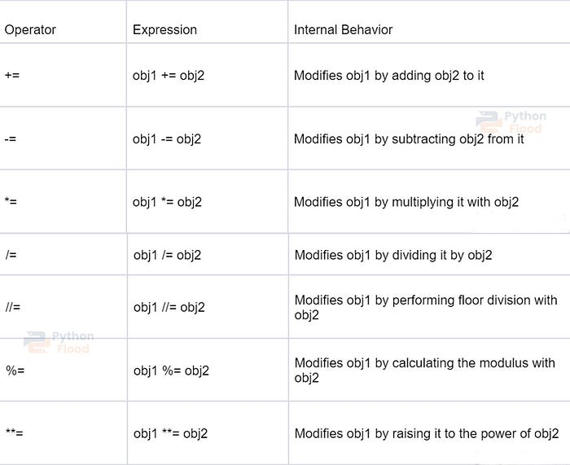

**3.3 Unary Operators:**

By customizing the behavior of unary operators (‘-’, ‘+’, ‘’, and ‘abs()’) for custom classes, unary operators in operator overloading enable the application of custom actions to objects. Some unary operators are provided below:  
— `__neg__(self)`: Implements the negation operator (-).  
— `__pos__(self)`: Implements the unary plus operator (+).  
— `__abs__(self)`: Implements the absolute value operator (abs()).

**Example:**

class Number:  
 def __init__(self, value):  
 self.value = value  
  
 def __neg__(self):  
 return Number(-self.value)  
  
 def __pos__(self):  
 return Number(self.value)  
  
 def __abs__(self):  
 return Number(abs(self.value))  
  
 def __str__(self):  
 return str(self.value)  
  
# Create a Number object  
num = Number(-5)  
  
# Unary negation operator  
neg_num = -num  
print(neg_num) # Output: 5  
  
# Unary positive operator  
pos_num = +num  
print(pos_num) # Output: -5  
  
# Absolute value operator  
abs_num = abs(num)  
print(abs_num) # Output: 5

**Explanation:**In this illustration, a number with a value attribute is represented by the Number class. The class defines the magic methods __neg__(), __pos__(), and __abs__() to overload the unary operators.  
The function __neg__() returns a new Number object with the negated value and overloads the unary negation operator (-).  
Unary positive operator (+) is overloaded by __pos__(), which also returns a new Number object with the same value.  
The abs() function is overloaded by __abs__(), which then produces a new Number object with the absolute value.  
In this illustration, a number with a value attribute is represented by the Number class. The class defines the magic methods __neg__(), __pos__(), and __abs__() to overload the unary operators.

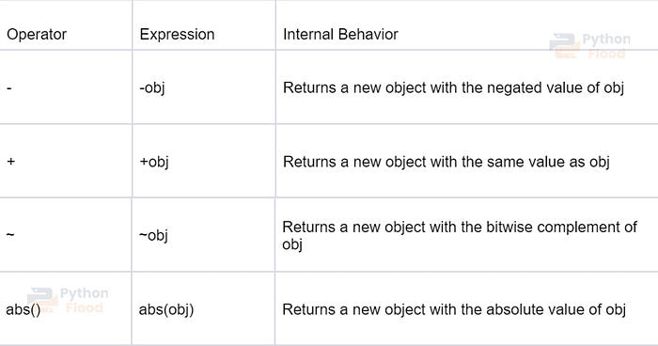

**4. Operator Overloading on Boolean Values:**

You can also overload operators for boolean values, allowing you to define custom behavior for logical operations. The following magic methods are commonly used:  
— `__bool__(self)`: Implements the bool() function and defines the truthiness of the object.  
— `__and__(self, other)`: Implements the logical AND operator (&).  
— `__or__(self, other)`: Implements the logical OR operator (|).  
— `__not__(self)`: Implements the logical NOT operator (~).

**Example**:

class Person:  
 def __init__(self, name, age):  
 self.name = name  
 self.age = age  
  
 def __bool__(self):  
 return self.age >= 18  
  
person1 = Person("John", 25)  
person2 = Person("Alice", 16)  
  
print(bool(person1)) # Output: True  
print(bool(person2)) # Output: False

**Explanation:**The Person class in this illustration represents a person with a name and an age. The bool() function is overloadable thanks to the __bool__ method. If the person is at least 18 years old, it returns True; otherwise, it returns False.

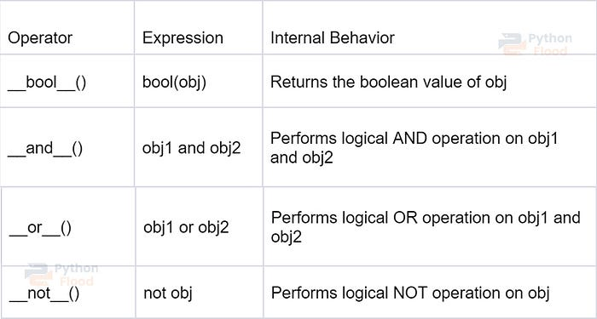

**5. Advantages of Operator Overloading:**

Operator overloading has various benefits, including improved code readability by allowing intuitive actions on bespoke objects, Increased expressiveness by the inclusion of mathematical and logical procedures and the ability to define custom syntax to develop domain-specific languages.

**6. Tips and Tricks:**

1. To prevent misunderstanding, operator overloading should be used selectively and in accordance with intuitive behavior.
2. Where appropriate, make sure the overloaded operators maintain commutativity.
3. To help other developers who use your code understand how overloaded operators behave, write down how they operate.

**Conclusion**

This guide provides an overview of [Python](https://www.python.org/) operator overloading, covering various aspects such as operator and magic methods, comparison operators, assignment operators, unary operators, operator overloading on boolean values, advantages, and code snippets. Use these concepts to enhance the functionality and expressiveness of your Python skills.